# Lab 5. [Using](https://preview.flow.microsoft.com/en-us/galleries/public/templates/7b4b0defab8145578a67108723b38095/get-my-manager-to-approve-a-travel-request/) the Microsoft Form Connector

**Author:** Serge Luca aka “Doctor Flow”

**Duration:** 15 minutes.

**Scenario:** In this lab, we will explore how to catch data submitted by Microsoft form. The case of a course evaluation will be implemented.

## Tasks:

1. Go to your Office 365 Applications and select **Forms**:

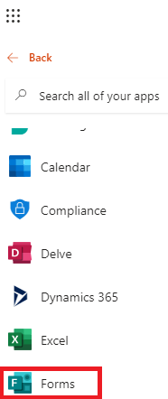

1. Click **New Form :**

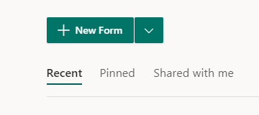

1. Name the form **Training evaluation**:

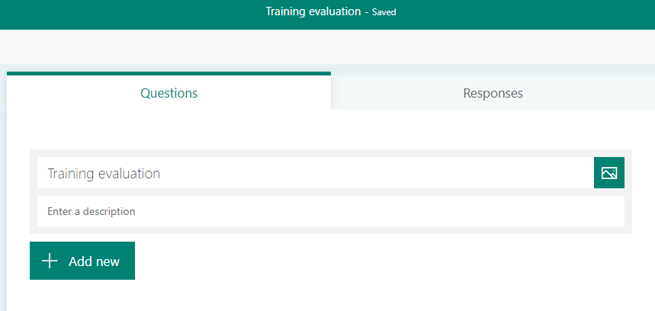

1. Click **Add new**, select **Text** and name the field **Your First Name**:

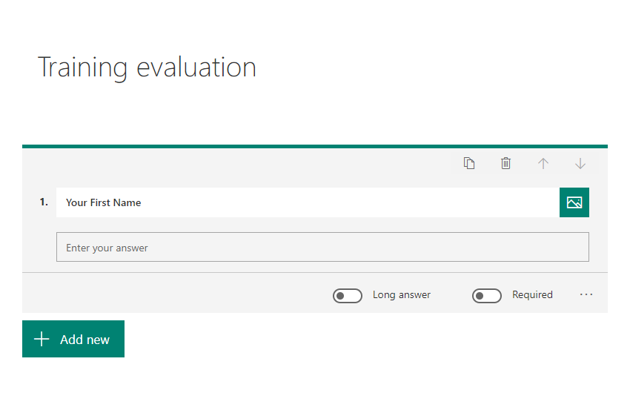

1. Proceed like this for the fields **Your Last Name**, and **your e-mail.**
2. Add a field How as the course content and Select rating

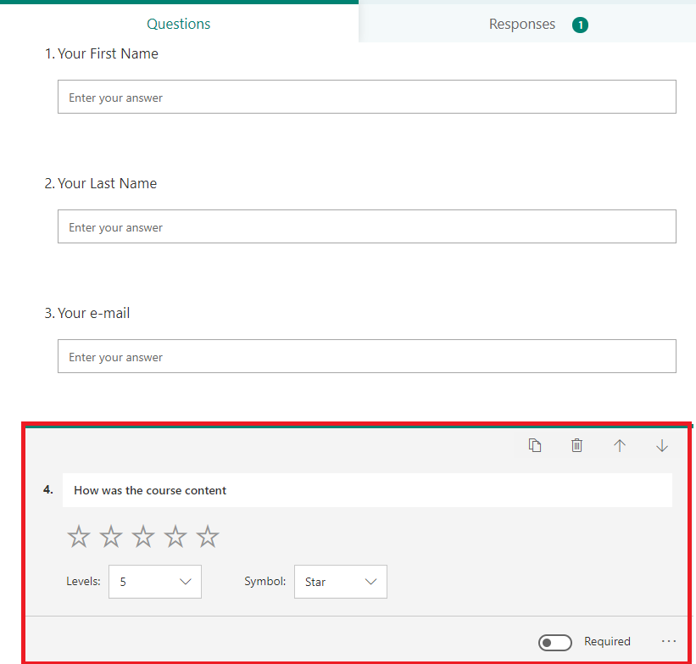

1. Add another rating for the trainer:

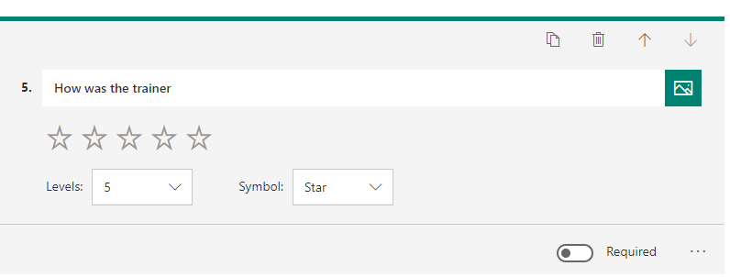

1. Click **Share**, click the QR Code icon and scan the QR code to Submit an evaluation.
2. Go to Power Automate and create a flow. Name it “Training evaluation”.
3. Select the trigger from the Form connector: the trigger should be **When a new response is submitted**

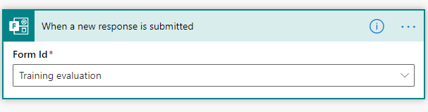

1. After the trigger add a new action **Get response details** from the Form connector; select the Form id **Training** evaluation and grab the **Response Id** from the trigger:

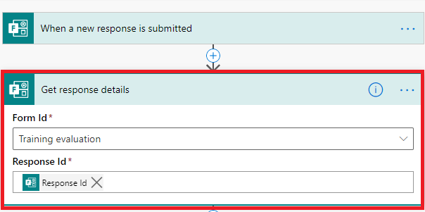

1. Add a Compose for each field of the response and bind them to their corresponding dynamic value:

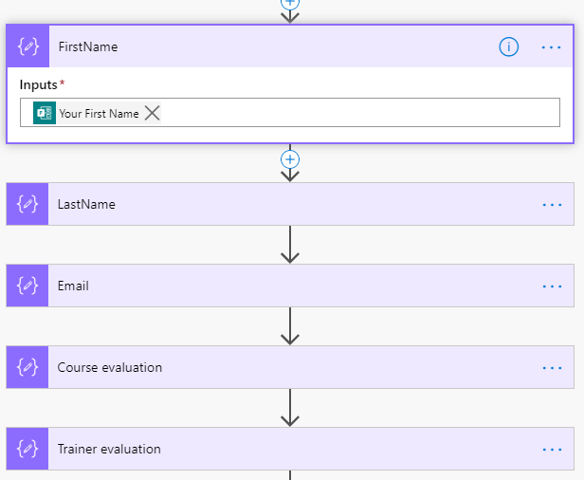

1. Check if one of the rating is less than 4; if that is the case, send an e-mail to yourself with the evaluation details: in the condition statement, don’t forget to use the **int()** function in order to compare the ratings to 4:

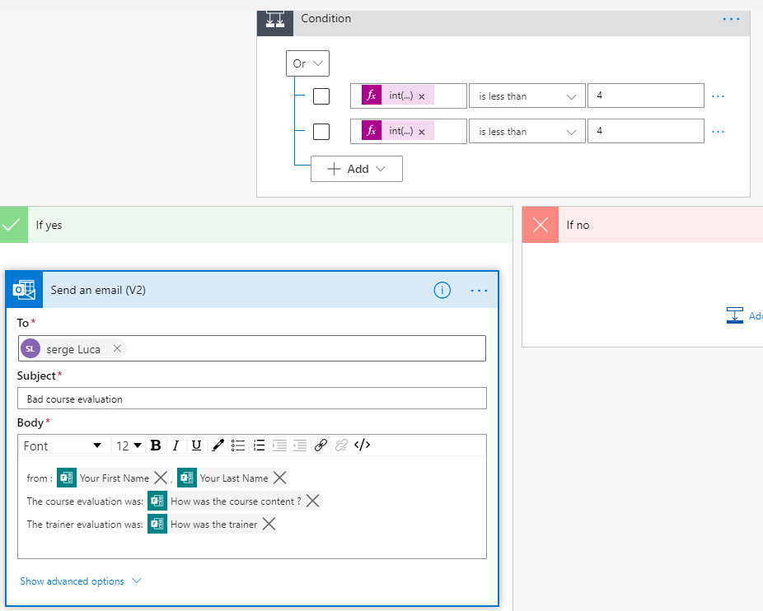

1. Submit a bad evaluation and check your e-mail.

## We need your feedback

Do you want to report an issue or to suggest something? We need your feedback: <https://github.com/Power-Automate-in-a-day/Training-by-the-community/issues>